

***Department of Computer Science & Engineering***

**Course Title –** Peripherals and Interfacing

**Course Code –** CSE 316

**Section** - A1

Final Project

***Sonic Shooter***

**Date of Submission –** April 23, 2022



**Motivation**

Shooting video games are growing popular each day. However, holding an actual shooting device is a whole different experience altogether, and significantly more fun for target practice.

This experience can be obtained through one of two ways: Shooting at an actual gun range with real weapons, which is immensely dangerous and often not worth the risk, cost, and additional effort. The other is doing so with non-lethal ammunition such as paint-ball, laser tag, and similar arrangements. However, these are quite expensive and require a lot of resources.

Considering these facts, we propose an inexpensive mini target practice system that utilizes the ultrasonic sensor to both shoot and confirm target hit.



**Objectives:**

* Use ultrasonic module to detect shots
* Popping-up targets
* Show score in LCD with sound

**Critical Challenges:**

Pin crisis:

Each servo motor takes 3 pins, therefore in total 3 motors would take 9. Even shorting some common ones, the LCD, speaker, trigger, and ultrasonic module in total required way more pins than the arduino uno could provide, therefore we had to resort to arduino Mega.

I2C LCD:

Not much well-defined documentation of I2C module led to the problem of hours of failed troubleshooting as the potentiometer was turned the other way.

Trigger:

Using push button as a trigger posed a problem as it was taking random input since there was not enough resistance to mask the electrical noise.

Linux OS:

As Linux OS was the operating system of the primary computer used in this project, it’s lesser compatibility led to port being undetectable and more of such issues.

Ultrasonic Module:

The ultrasonic module malfunctioned when the target had a soft surface.

Speaker:

The tone() function was unable to produce very loud sounds at the desired frequency.

**Power:**

The motors taken from lab were of the model mg995. This motor is about ten times more powerful than the sg series ones and they require massive amount of power.   
However, as the project already had multiple components, the power deficiency problem was even more potent. This made us try several methods to power the motors, however, each of them were proven futile. Using a power supply module, external power source via powerbank, using a USB cable with its internal wires connected to the power supply module – each of the attempts failed. Finally at the demonstration day, a borrowed sg series motor was used to demonstrate the project.

**Conflicting Requirements:**

All components needed supply of power simultaneously, However, the significant number of components were drawing up too much power and it resulted in not enough being left to power each component perfectly.

# **Complex Engineering Problem & Mapping:**

* **Ks in the project:**

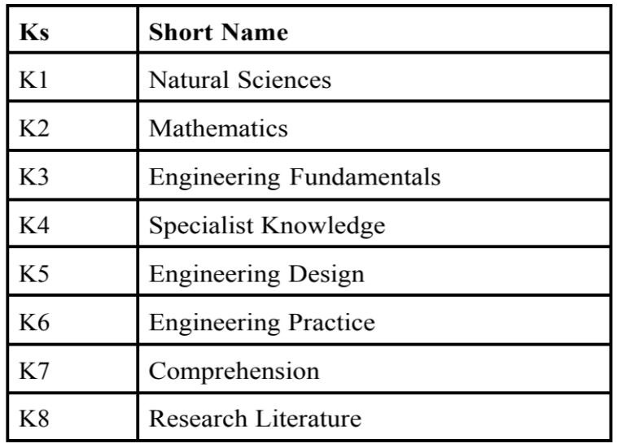

* **A’s in the project:**

| **Attribute** | **P1 and some or all of P2 to P7:** |
| --- | --- |
| **Depth of knowledge required** | **P1**: one or more of K3, K4, K5, K6 or K8 |
| **Range of conflicting requirements** | **P2**: wide-ranging or conflicting technical, engineering and other issues |
| **Depth of analysis required** | **P3**: no obvious solution |
| **Familiarity of issues** | **P4**: Involve infrequently encountered issues |
| **Extent of applicable codes** | **P5**: outside problems encompassed by standards and codes of practice |
| **Extent of stake-holder involvement and conflicting requirements** | **P6**: diverse groups of stakeholders with widely varying needs |
| **Interdependence** | **P7**: many component parts or sub-problems |

* **How P’s are addressed through the project:**

| **Ps** | **Attribute** | **How Ks are addressed through the project** | **COs** | **POs** |
| --- | --- | --- | --- | --- |
| **P1** | Depth of Knowledge Requirement | Our project requires Arduino Programming (K2), rigorous study of existing projects(K8),  Engineering Fundamentals(K3) | CO1  CO2  CO3  CO7 | PO1  PO2  PO3  PO5 |
| **P3** | Dept of Analysis Requirement | Project’s requirements, component data | CO4  CO7 | PO2  P12 |
| **P4** | Familiarity of Issues | We needed to Analyze & implement various programming knowledge and skills to fix Many issues | CO7 | PO3  PO9 |

* **How As are addressed through the project:**

| **Ps** | **Attribute** | **Ps are addressed through the project** |
| --- | --- | --- |
| **A1** | Range of Resources | Various resources had been used such as 3 team member involvement(people), the budget was crossed multiple times(money), equipment (from lab and personally bought) etc. |
| **A2** | Level of Interaction | Successful interaction between multiple components |
| **A3** | Innovation | A novel way of using ultrasonic to detect target and also use as ammunition for shooting game was introduced |
| **A5** | Familiarity | Most of the components used, were familiar, along with the programming language being based of C. |

* **How COs are addressed through the Project:**

| **Ps** | **CO Statements** | **Corresponding POS** |
| --- | --- | --- |
| **CO1** | Identifying a real-life problem that can be transmitted to an engineering or computing solution through design, development and validation. | PO4  PO10  PO12 |
| **CO2** | Identify, formulate and analyze a real world compels engineering problem based on requirement | PO2  PO3 |
| **CO4** | Use a modern/popular IDE to test complex software-intensive systems. | PO7 |
| **CO7** | Work as a team and fulfill individual responsibility | PO9 |